EE-451 - Image analysis and pattern recognition – Prof. Jean-Philippe Thiran Spring 2022

List of questions for the interviews

Part 1 – long answers

1. **Present how to perform geometrical transformations of a digital image? Take the example of a translation of a non-integer number of pixels. L1 s12**

Main idea: leave the grid where it is and find the values of pixels s.t. the image looks transformed. Translation of a non-integer number of pixels as example, find place of the red pixel in the original image by inverse transformation and interpolate the value of that pixel to put it back into the new image (free choice of kernel depending on computational power, speed needed, accuracy needed. Ideal: sinc). Nonlinear transformation can also be performed with the same procedure such as polynomial transformations.

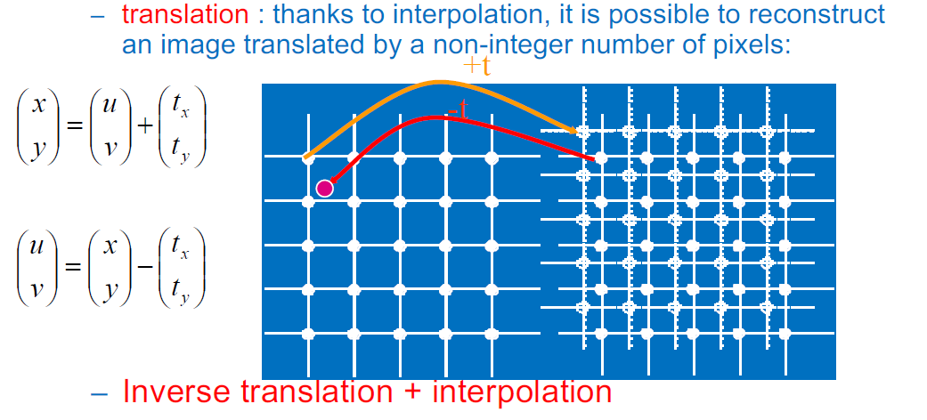

1. **What is image restoration? On this context what is inverse filtering and what is a Wiener filter? L1 s36**

Observed image:

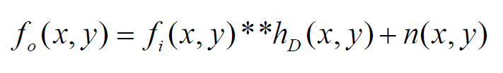

Restored image:

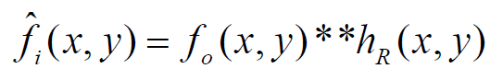

Fourier transform:

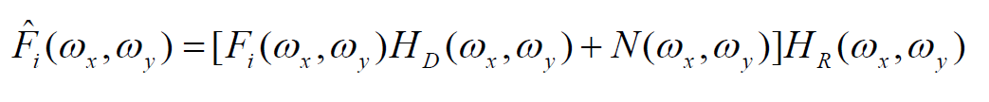

Naive inverse filter:

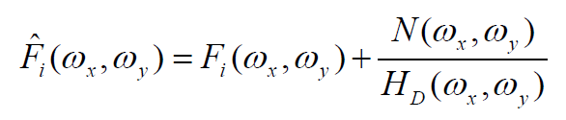

Hd often low-pass (blur) 🡪 1/Hd amplifies the high frequencies of the noise

But if no noise: ideal filter!

Wiener Filter: We want to minimize the expected reconstruction error

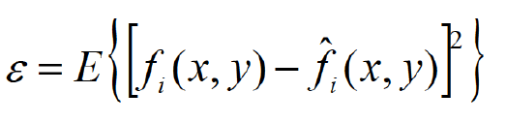

After some calculation we get

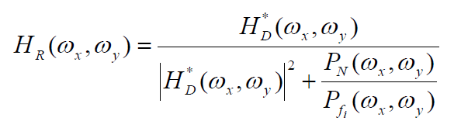

Pn power spectrum of the noise

Pfi power spectrum of the image

Adaptive band-pass filter:

* Large noise 🡪 Hr vanishes (attenuates noisy frequencies)
* Little noise 🡪 1/Hd ideal inverse filter for low-noise frequencies

Estimation of Hd and noise power spectrum Pn

* Pn can be estimated from uniform region of the image, remove mean and compute FT of autocorrelation function
* Hd is the impulse response, can be estimated by a region of the image containing something looking like a dirac (star in the sky) or by deriving the step response from an edge on the image and derive it to get the impulse response.

1. **Explain what object labeling is and the algorithm to implement it. L2 s15**

Object labeling aims at separating semantically different objects in an image by labeling the pixels of that image. Objects are defined by connex regions that are below a certain predefined threshold.

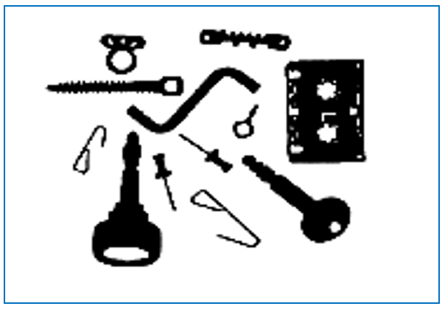

Scan the image from the top left (0,0) until finding a pixel under the threshold. Find all connected pixels (connex region) under threshold with region growing and assign them the same label, then start scanning again unlabeled pixels. Do so until all pixels are all labeled.

1. **What are the main principles of edge detection, and the two main families of methods to do edge detection? Present typical methods for each family. L2 s20**

Identify edges in an image at which the intensity sharply changes, i.e. when the derivative has a maximum.

1. Maximum of first derivative

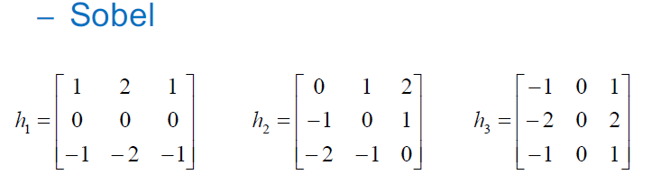

1. Laplacian of Gaussian (LoG):

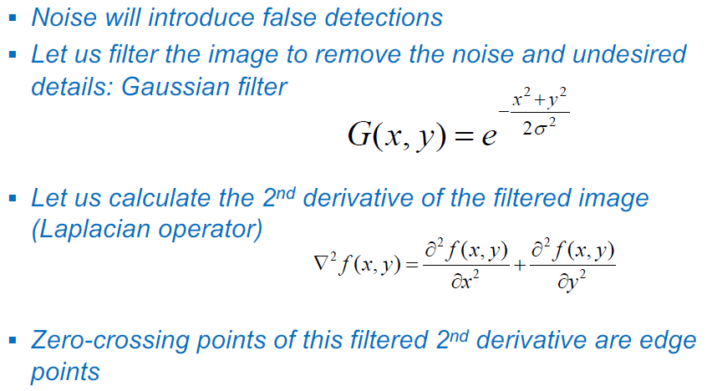

Trick: Exploit property of convolution:

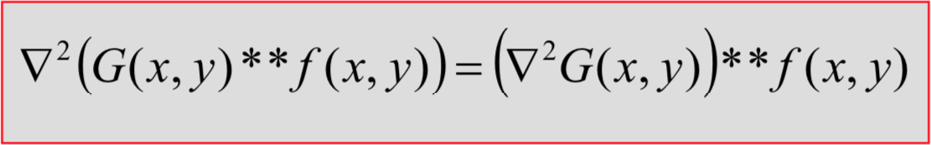

* Convolve image with the second derivative of a Gaussian and find zero-crossing to detect edges

1. **What are the 4 main operators of binary mathematical morphology? Explain each of them. L2 s28-37**

* Dilation & erosion (change the size of the object)
* Opening and closing (fill holes inside or external to the object)

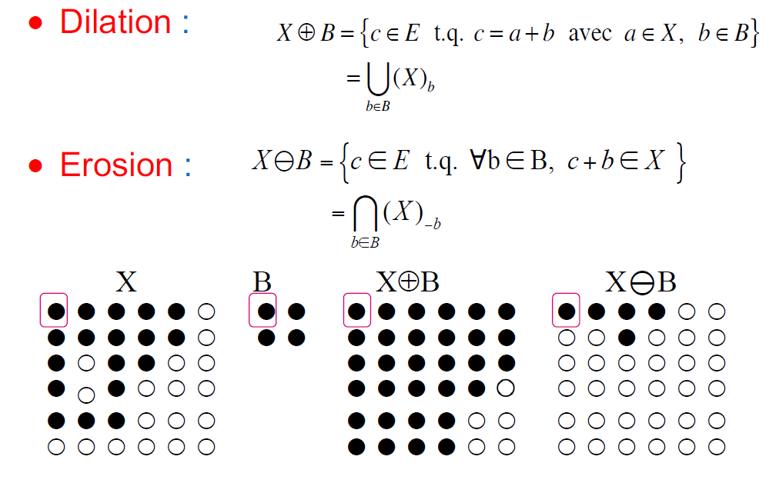

Dilation: Expansion of the object by the structural element. Fills holes that are smaller than the structuring element. Increases the size of the object

Erosion: Removes parts of the object where the structuring element doesn’t fit entirely. Decreases the size of the object.

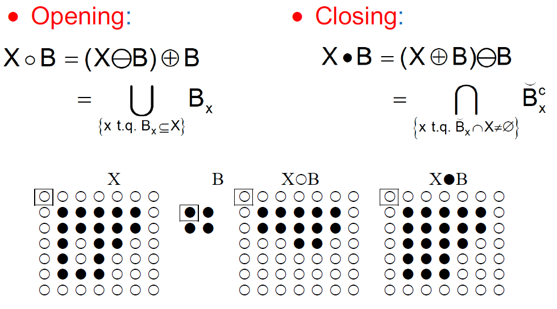

Opening: Erosion then Dilation. Remove the external parts that are smaller than the structuring element. Opened object is a subset of the original.

Closing: Dilation then Erosion. Fill holes in the objects that are smaller than the structural element. Closed object is a superset of the original.

1. **What are the Fourier descriptors? L4 s22-30**

Feature based on the Fourier transform of the contour of an objet. Define contours as complex numbers: 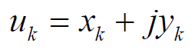, compute DFT….

The first Fourier descriptors contains most of the information on the shape of the object.

Translation invariance:

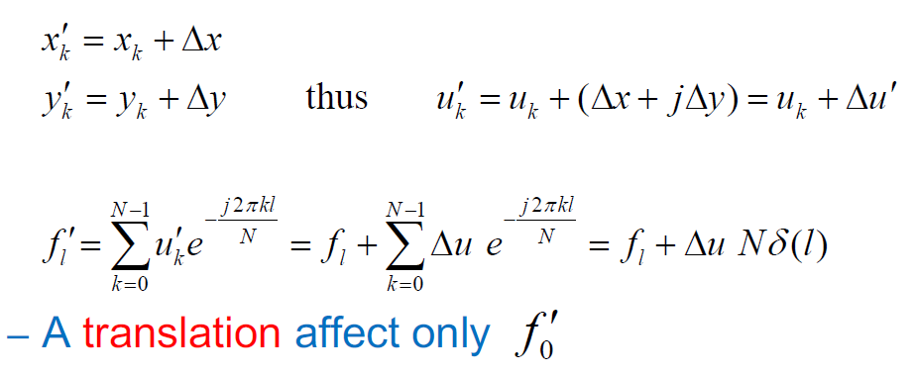

* Don’t take the first coefficient into account

Rotation invariance:

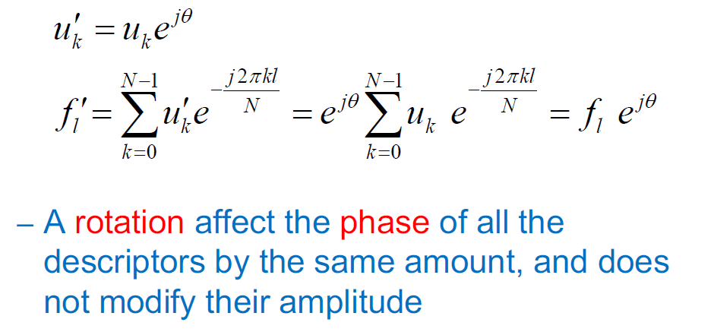

* Ignore the phase of all descriptors

Scale invariance:

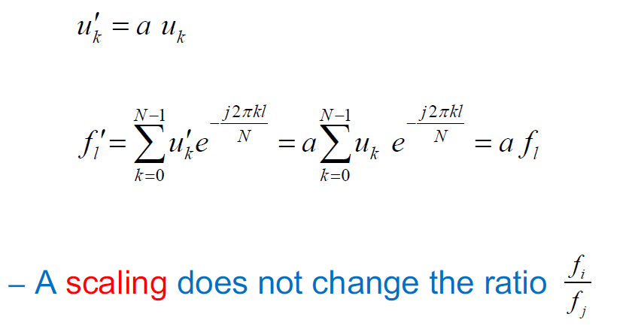

* Normalize the Fourier coefficient

1. **What is a Freeman code? L3 s11**

Idea: encode the contour thanks to labeled directions (1,2,3,…)

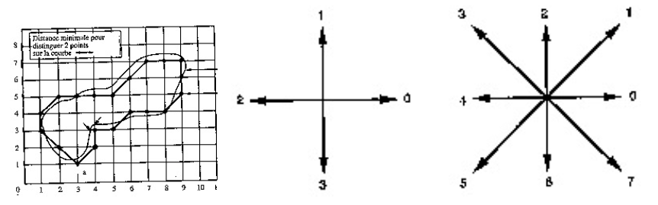

Compact representation, directions encoded in 3 bits only.

Compare object by computing similarity between codes of 2 different objects:

Edition distance: Minimum number of elementary operations to go from one chain to the other.

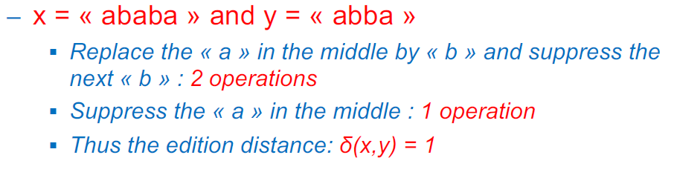

Algorithms to compute the edition distance: Fisher-Wagner

1. **What is a morphological skeleton? L3 s18**

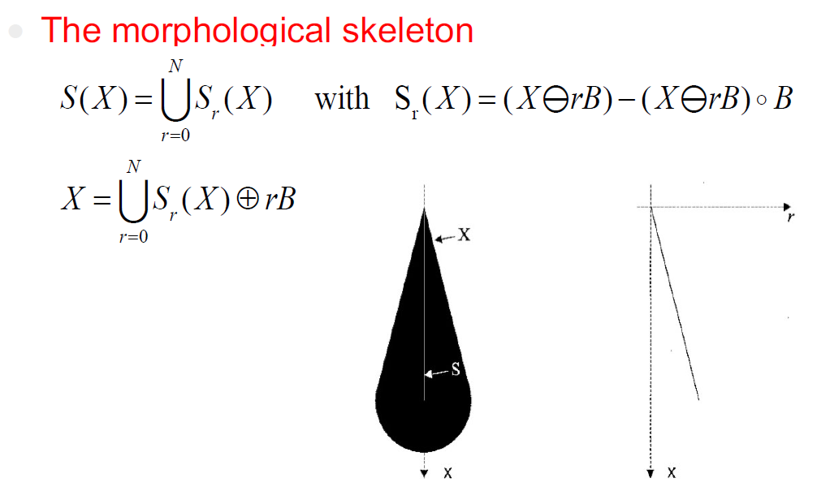

S1(X)

S0(X)

Sr(X) = X eroded by rB – (X eroded by rB then opened by B)

B very small structuring element

Object is encoded in the skeleton and can be reconstructed using the same B.

This is a flexible descriptor in the sense that we can ignore the part of the skeleton with small values of r in order to consider the largest part of the object. Doing so for a human shape for example, we can ignore the position of the arms and focus on the body.

Multi-scale representation of the object, useful to compare object.

1. **What is a Bayesian classifier? (principle, advantages & limitations, application to Gaussian cases) L4 s7**

Supervised learning

Datapoint x, class wi:

We want to approximate P(wi|x) to answer the question: To which class the sample x is most likely to belong to?

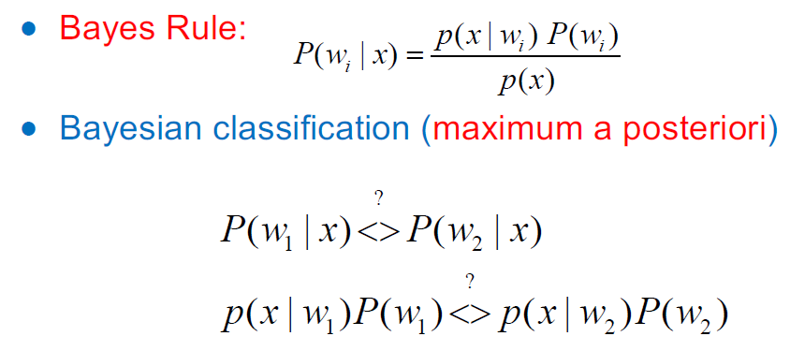

Because p(x) doesn’t depend on wi 🡪 we can ignore it

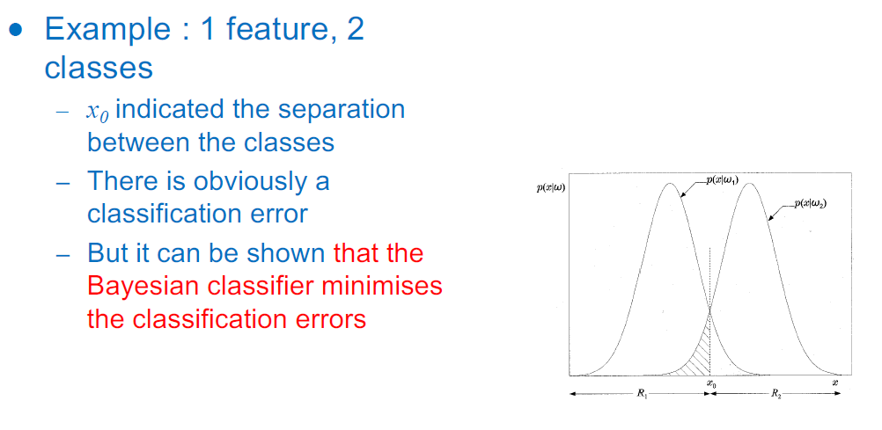

Generalizable to n classes :

Decision surface between class i and j: P(wi|x) – P(wj|x) = 0

> 0 🡪 more likely to be in class i

< 0 🡪 more likely to be in class j

Gaussian case: if we assume that p(wi|x) are Gaussian, we can take the logarithm

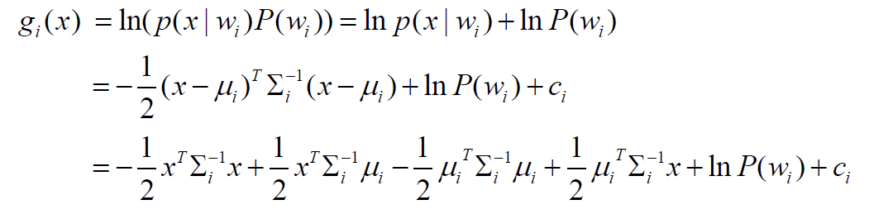 as discriminant function:

Special case:

* Common covariance matrix for all classes

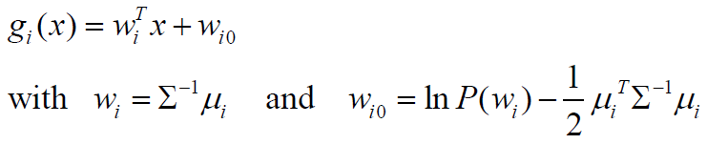Discriminant becomes

Decision surfaces are

hyperplanes

Part 2 – short answers

1. **What is a Median filter?**

For each pixel:

1. Consider nxn neighborhood
2. Sort the pixels value in ascending order
3. Set the median value (middle of the list) to that pixel

Advantages: Supresses small variations and keeps the contours

Very effective for “salt and pepper” kind of noise

1. **What is the Laplacian of Gaussian (LoG) method for edge detection? (this question cannot be taken if question 4 is taken in Part 1)**

See Q4 in part 1

1. **How do we calculate the axes of inertia of a binary object?**
2. **What is a Euclidean distance classifier?**
3. **What is a Mahalanobis distance classifier?**
4. **What is a k-NN classifier?**
5. **What is a linear perceptron and how can we train it?**
6. **What is a Multi-layer perceptron?**
7. **What is supervised and non-supervised classification?**
8. **What is non-supervised classification and describe the k-means algorithm?**